Ideation Phase

# Define the Problem Statements

Date: 19 May 2025

Team ID:

Project Name: Video Conferencing App

Maximum Marks: 2 Marks

## Customer Problem Statement Template:

To define the core problems users face while conducting video calls or meetings online, and use those insights to guide the development of the Video Conferencing App.

Reference: https://miro.com/templates/customer-problem-statement/

|  |  |  |  |  |  |
| --- | --- | --- | --- | --- | --- |
| Problem Statement (PS) | I am (Customer) | I’m trying to | But | Because | Which makes me feel |
| PS-1 | remote employee | attend team video calls without installing software | most platforms need sign-in or app download | my organization blocks external apps | excluded and unproductive |
| PS-2 | online educator | deliver classes smoothly to students | video/audio often lags or drops | platforms don't support P2P optimization | frustrated and ineffective |
| PS-3 | startup founder | host private investor calls securely | free tools log and store call data | we handle sensitive information | worried about confidentiality |
| PS-4 | freelancer | jump into calls quickly with clients | platforms require complex setups or accounts | clients are non-technical | losing opportunities |

Below is a visual representation of the Customer Problem Statement framework:

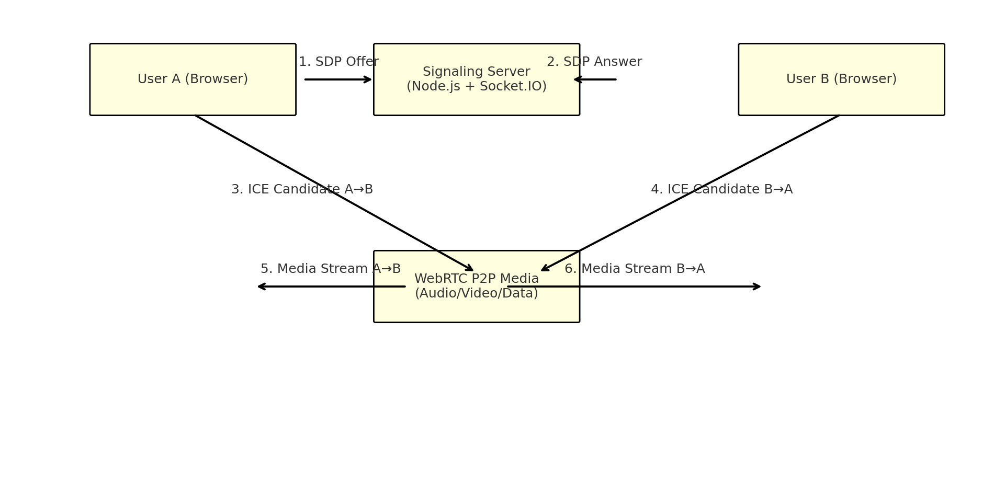

Customer Problem Statement Template Reference:

